Indoor localization method based on template matching VO and MCPES

Jianhao Yu, Yuhua Huang, Qingxi Zeng, Bangjun Ou , HaoNan Yu

|  |
| --- |
|  |
| *Abstract*—In the field of robotics, indoor positioning and navigation are core problems of robotics applications. However, commonly used motion capture systems are expensive and difficult to configure. Moreover, current localization algorithms based on monocular and binocular stereo vision are limited by their high cost and the environment. This paper proposes a low-cost and easy-to-implement robot localization method for large indoor scenes. First, we install inexpensive landmarks on the top of the mobile robot and use the camera to determine their pose, and then we design an indoor global positioning system based on a multi-camera coordinate system. Next, we introduce template-matching visual odometry to enhance the MCPES system. We demonstrate that our method provides long-term precise positioning of the robot in a large scalable environment with a positioning accuracy of 20 mm. In addition, our algorithm can still obtain the pose information of the robot after camera tracking fails and achieve continuous positioning.  *Index Terms*—Indoor Positioning, Global Positioning, SLAM, Template Matching, Visual Odometry. |
|  |

# [1] Introduction

S

LAM (Simultaneous Localization and Mapping) is a critical technology in the field of robotics, providing positioning [1][2], real-time map generation [3], navigation [4], navigation performance assessment [5], and SLAM accuracy assessment [6]. Locating technology is one of the key problems of the robot SLAM system, which guarantees the robot's autonomous movement and mission execution. In recent years, more attention has been paid to the development of benchmark positioning methods for robot positioning. Benchmarking method have been widely adopted for path planning and location accuracy assessment, as shown in [3], where high-precision ground truth information with 1 cm accuracy was provided by external cameras covering a 25 m2 area. For SLAM, one of the first attempts was Radish's dataset, an open dataset shared by researchers around the world to evaluate and compare algorithms. Mike provides a large dataset for mobile robotics research [9], and Amigomi's mapping method can be used to compare different open-source algorithms [10].

It is widely recognized that a robot's position and motion state accuracy may be subject to cumulative errors that arise from variations in the robot's linear velocity and rotational direction [6]. Unlike outdoor global positioning schemes, such as GPS (Global Positioning System), which depend on uninterrupted communication between the receiver and the satellite, indoor environments are typically characterized by occlusion, which precludes such solutions for indoor robots. As such, there is an urgent need to develop reliable and accurate indoor robot positioning solutions that can address the unique challenges of indoor environments.

The Rawseeds project [11][12], containing sensor datasets, as well as benchmark problems and solutions, has made significant efforts to create benchmark datasets of SLAM data with ground-level real-time information. Ground real-time data is acquired through a set of fixed lasers and cameras throughout the environment, all of which are calibrated together. The vision system has an accuracy of 112 mm and -0.8°, and the laser system has an accuracy of 20 mm and 0.2°. The SLAM map of the University of Freiburg [13], proposes to use the relative relationship between poses to measure the performance of SLAM systems. All calculations are based on the trajectory correction of the robot, regardless of the global coordinate system and environment model. The RGB-DSLAM dataset and landmarks presented by Sturm et al. acquired real-time data on the ground using a motion capture system with an accuracy of 10 mm and 0.5°.

The Rawseeds project [11][12] has made significant strides in developing benchmark datasets for Simultaneous Localization and Mapping (SLAM) data, which include ground-level real-time information. This project incorporates a set of fixed lasers and cameras throughout the environment that are calibrated together to acquire ground real-time data. The vision system has an accuracy of 112 mm and -0.8°, while the laser system has an accuracy of 20 mm and 0.2°. The SLAM map of the University of Freiburg [13] proposes using the relative relationship between poses to evaluate the performance of SLAM systems. All calculations are based on the trajectory correction of the robot, independent of the global coordinate system and environment model. Sturm et al. presented the RGB-DSLAM dataset and landmarks that use a motion capture system with an accuracy of 10 mm and 0.5° to acquire real-time data on the ground.

Recently, the field of indoor visual localization and mapping has seen significant advancements, particularly through the application of deep learning techniques. For example, Wang et al. [14] proposed a keypoint detection and matching system based on deep learning, which can be used for indoor robot localization. Gu et al. [15] presented a scalable and robust 6-DoF localization system that utilizes multi-view RGB-D fusion, achieving high accuracy in various indoor environments. Ghamisi and Benediktsson [16] proposed a 2.5D CNN-based visual localization and mapping system that is both robust and efficient, while Zhang et al. [17] presented an efficient and robust feature extraction system that can be used for visual localization in indoor environments.

Monocular camera systems have also been introduced as a recent development for indoor visual localization. Du et al. [18] proposed an efficient and robust monocular visual odometry system that uses artificial landmarks for indoor navigation. Kang et al. [19] presented a Siamese convolutional neural network-based visual localization system that achieves high accuracy and efficiency. Kim et al. [20] proposed an indoor positioning and navigation system based on visual SLAM for mobile robots.

Moreover, Abdelkader et al. [21] introduced a deep learning-based object detection and tracking system for indoor navigation of mobile robots. These recent advancements in indoor visual localization and mapping have led to the development of more accurate and robust indoor positioning solutions, which are in high demand for indoor robots and autonomous systems. With the continued development and evaluation of new techniques and systems in this field, it is likely that we will witness even more significant advancements in the years to come.

[14] Wang, X., Li, Y., Gao, X., Li, X., & Li, H. (2019). Deep learning-based indoor robot localization using keypoint detection and matching. Sensors, 19(18), 3836.

[15] Gu, Z., Wang, Y., Zhao, Y., & Liu, M. (2019). A scalable and robust 6-DoF localization system in indoor environment. Robotics and Autonomous Systems, 117, 103-115.

[16] Ghamisi, P., & Benediktsson, J. A. (2017). 2.5D CNN-based visual localization and mapping using geotagged images. ISPRS Journal of Photogrammetry and Remote Sensing, 132, 60-76.

[17] Zhang, Y., Song, W., & Wang, Y. (2020). Fast and efficient indoor visual localization using robust features extraction. IEEE Access, 8, 93206-93216.

[18] Du, J., Cao, H., Yu, Y., Yang, X., & Sun, X. (2020). Efficient and robust monocular visual odometry system for indoor navigation. Sensors, 20(14), 3863.

[19] Kang, S., Kim, Y., & Yu, H. (2018). Robust visual localization using Siamese convolutional neural network for indoor navigation. Sensors, 18(9), 2918.

[20] Kim, J., Lee, H. J., & Kim, J. H. (2017). Indoor positioning and navigation system based on visual SLAM for mobile robots. IEEE Transactions on Industrial Electronics, 64(10), 7712-7721.

[21] Abdelkader, M., Mohamed, M., & Abdelsamea, M. (2021). Deep learning-based object detection and tracking system for indoor navigation of mobile robots. Robotics and Autonomous Systems, 135, 103744.

These landmark devices rely on pre-recorded data and real-time ground data. Because the data is acquired from a specific device in a specific environment, it is difficult to compare solutions using different sensor suites optimized for different environments.At the same time, these systems are always difficult to reconfigure and costly. Compared with the traditional motion capture systems, the system based on the placement of landmarks on the ceiling and the upward camera on the robot proposed by Harsha [14] is a relatively inexpensive indoor positioning solution with high precision and robustness. Recently, the scheme of placing landmarks on robots proposed by Li [15] has the same cheap and high accuracy and is more portable, but the system is only suitable for small environments and cannot be used in large ones.

There are two methods for estimating robot position based on vision: one is the feature method, and the other is the appearance method [16]. Appearance-based methods obtain the appearance changes of the image and the intensity of pixel information in it. Template matching is a representative method of the appearance method, which is very suitable for low-texture scenes [17]. In our work, we propose a system based on a multi-camera group and two pairs of landmarks to construct maps [18]. With two landmarks placed on top of the robot, we can obtain the pose of the robot relative to the camera. Meanwhile, the landmark localization method we use has the characteristics of low cost and high accuracy [19]. Compared with [15], our system has the scalability of large-scale scenes and can track and localize robots in real-time in indoor scalable scenes. Meanwhile, we introduce template-matching visual odometry to deal with the occlusion problem during localization. And we only use one processor to complete the construction of the positioning system, which can make the positioning and collaborative work of multiple robots easier. The main contributions of our work can be summarized as:

(1) The MCPES (Multi-camera Pose Estimate System) system is proposed, a landmark-based indoor positioning scheme for wide-area scenes, so that the robot positioning can be extended to the scene.

(2) An indoor localization algorithm combining MCPES and template-matching VO(Visual Odometry) is proposed, which improves the robustness of the system.

(3) The relevant experiments are carried out in an indoor environment to verify the effectiveness of the system.

The rest of this article is as follows. The second chapter introduces the MCPES system and its realization process. The third chapter introduces the basic theory and realization method of template matching visual odometry; the fourth chapter introduces the concrete realization steps of the indoor positioning method combining MCPES and template matching. The fifth chapter verifies the effectiveness of the algorithm through several sets of experiments. The sixth chapter is the conclusion.

# Multi-camera pose estimation system

## System Overview

We propose MCPES, which is a vision-based optical solution for the autonomous positioning of robots in large indoor scenes. The frame diagram is shown in Fig 1. The system flowchart is shown in Fig 2.

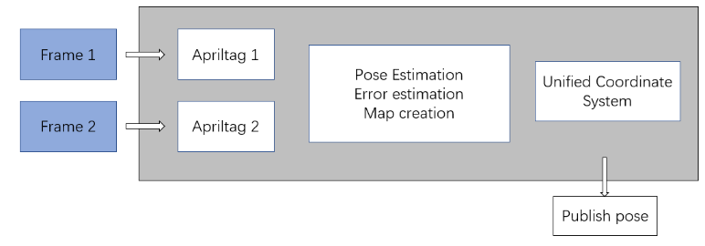

Fig. 1. MCPES system frame diagram.

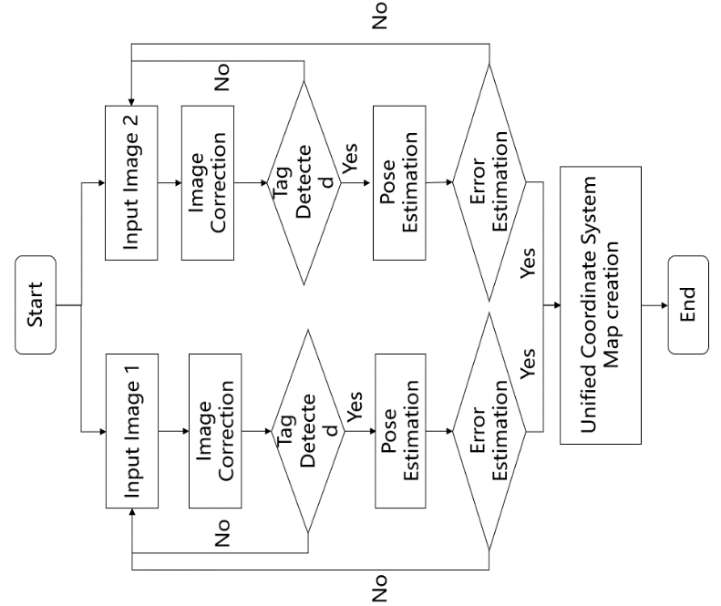

Fig. 2. MCPES system flowchart

## Multi-camera pose estimation system

MCPES (Multi-camera pose estimation system) is an optical solution for the autonomous positioning of mobile robots in large indoor scenes. This solution uses multiple cameras and a landmark placed on top of the mobile robot to provide real-time pose information of the mobile robot. The main idea is to first estimate the pose of the mobile robot with a single camera, and then unify the coordinate systems of multiple cameras to obtain real-time pose information, as shown in Figure 3.

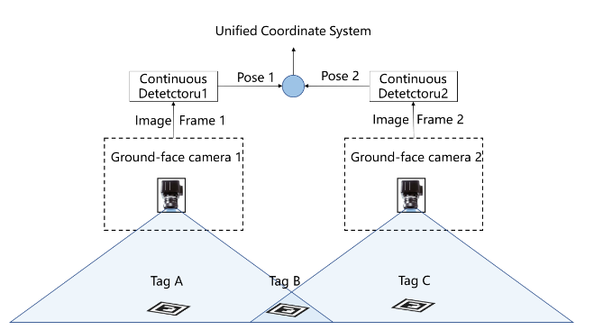

Fig. 3. MCPES system

The landmarks we use are Apriltag proposed by Edwin Olson [20], as shown in Figure 4. This landmark differs from 2D landmark QR codes [21] in that it uses fewer pixels while providing more effective information. This landmark can often also be used for basic motion capture.

The MCPES system consists of multiple cameras, several optical markers, and processing procedures. Several cameras are randomly placed on the ceiling, but the fields of view between the cameras are required to overlap. First, we calibrate the cameras with a checkerboard and calculate the intrinsic parameters of each camera, such as camera focal length, distortion matrix, image center, pose, inter-camera extrinsic parameter matrix, etc. Then the robot moves in the ROI (region of interest) of different cameras, and the pose information of the robot in different camera coordinate systems can be obtained. Finally, we unified the poses of the robots in the coordinate systems of several cameras and obtained the indoor coordinate system of a wide area and the pose of the mobile robots in this coordinate system. The system can realize the positioning of the robot in different indoor space areas and wide-area indoor environments.

The multi-camera joint positioning has the following steps:

### Image correction

$$\begin{aligned}\begin{aligned}x^{'}=\frac{u-c_{x}}{f_{x}} \\ y^{'}=\frac{v-c_{y}}{f_{y}}\end{aligned}\#\left(1\right)\end{aligned}$$

$$\begin{aligned}\begin{aligned}x^{''}=x^{'}⋅\left(1+k_{1}⋅γ^{2}+k_{2}⋅γ^{4}\right)+2⋅P_{1}⋅x^{'}⋅y^{'} \\ +P_{2}⋅\left(γ^{2}+2x^{'2}\right) \\ y^{''}=y^{'}⋅\left(1+k_{1}⋅γ^{2}+k_{2}⋅γ^{4}\right)+P_{1}⋅\left(γ^{2}+2⋅y^{'2}\right) \\ +2⋅P_{2}⋅x^{'}⋅y^{'}\end{aligned}\#\left(2\right)\end{aligned}$$

$$\begin{aligned}\left[\begin{aligned}u_{d} \\ v_{d} \\ 1\end{aligned}\right]=\left[\begin{matrix}f_{x} & 0 & c_{x} \\ 0 & f_{y} & c_{y} \\ 0 & 0 & 1\end{matrix}\right]⋅\left[\begin{aligned}x^{''} \\ y^{''} \\ 1\end{aligned}\right]\#\left(3\right)\end{aligned}$$

Where ${ (x}^{'}{,y}^{'}$) is the position ($u,v$)in the real image imgR after projective transformation and coordinate system transformation, ${(x}^{''}{,y}^{''}$) is the distortion position coordinate of any point in the distorted image with the camera coordinate system as the origin, where $k_{1}$ and $k_{2}$ are the mirror deformation coefficients, $P_{1},P_{2}$ are the tangential deformation coefficients; $γ$ is the radius from the current pixel point to the center of the circle, $γ^{2}={(u-x^{'})}^{2}+{(v-y^{'})}^{2}$.

After the transformation of formulas (1), (2), and (3), the corresponding relationship between the real image pixels and the distorted image pixels is obtained, so that the pixel values of $\left(u_{d},v_{u}\right)$ in the distorted image imgD are inserted into imgR $\left(u_{ },v_{ }\right)$.

### Apriltag positioning

#### Calculate the homography matrix

A homography matrix can project 2d points in the landmark coordinate system into the image coordinate system. The homography matrix is computed by direct linear transformation (DLT) [22]. Calculated as follows:

$$\begin{aligned}\left[\begin{matrix}h_{00} & h_{01} & h_{02} \\ h_{10} & h_{11} & h_{12} \\ h_{20} & h_{21} & h_{22}\end{matrix}\right]=sPE \\ =s\left[\begin{matrix}\frac{1}{f_{x}} & 0 & 0 & 0 \\ 0 & \frac{1}{f_{y}} & 0 & 0 \\ 0 & 0 & 1 & 0\end{matrix}\right]\left[\begin{matrix}R_{00} & R_{01} & T_{x} \\ R_{10} & R_{11} & T_{y} \\ R_{20} & R_{21} & T_{z} \\ 0 & 0 & 1\end{matrix}\right]\#(4)\#\end{aligned}$$

Where s is the scale factor of the transformation, P is the projection matrix, E is the external matrix; $fx$ and $fy$ are the focal lengths in the x and y directions of the camera, $R_{ij}$ is the rotation component, and $T_{k}$ is the translation component.

#### Landmark positioning

The actual position of the label plate can be obtained by the homography matrix, the formula is as follows:

$$\begin{aligned}\left[\begin{aligned}u_{1} \\ v_{1} \\ 1\end{aligned}\right]=\left[\begin{matrix}h_{00} & h_{01} & h_{02} \\ h_{10} & h_{11} & h_{12} \\ h_{20} & h_{21} & h_{22}\end{matrix}\right]⋅\left[\begin{aligned}u_{2} \\ v_{2} \\ 1\end{aligned}\right]\#\left(5\right)\end{aligned}$$

Where $s$ is the scale factor, ImgR $\left({u_{ }}_{2},{v_{2}}_{ }\right)$ is the midpoint coordinate of the Tag on the actual image, and ImgW $\left({u_{ }}_{1},{v_{1}}_{ }\right)$ is the physical actual position of the point.

### Coordinate system

We use kalibr to calibrate multiple cameras. The steps are as follows: After obtaining the external parameter matrices of cam_0 and cam_1, relocate the landmark pose in cam_1 and unify it into the world coordinate system. The formula is as follows:

$$\begin{aligned}\left[\begin{aligned}x_{1} \\ y_{1}^{'} \\ z_{1}^{'} \\ 1\end{aligned}\right]=\left[\begin{matrix}R_{00} & R_{01} & R_{02} & T_{0} \\ R_{10} & R_{11} & R_{12} & T_{1} \\ R_{20} & R_{21} & R_{22} & T_{2} \\ 0 & 0 & 0 & 1\end{matrix}\right]⋅\left[\begin{aligned}x_{1} \\ y_{1} \\ z_{1} \\ 1\end{aligned}\right]\#\left(6\right)\end{aligned}$$

Where $[x_{1} y_{1}^{ } z_{1}^{ } 1]$ is the center position of the landmark in the image, $[{x'}_{1} y_{1}^{' } z_{1}^{' } 1]$ is the landmark in the cam_1 perspective after the coordinate system 1 and the cam_0 coordinate system in the location.

## Error Estimation System

This paper uses the error estimation scheme proposed by Li [15], using Apriltags as optical landmarks to provide location and orientation information in real time. The main idea is to compare the estimated distance of two optical landmarks with the physical distance and estimate the reliability of the positioning system by the error, as shown in Figure 4. We use an Apriltag-based error estimation metric. Because unique identification numbers are used, landmarks can be tracked stably and errors can be estimated.

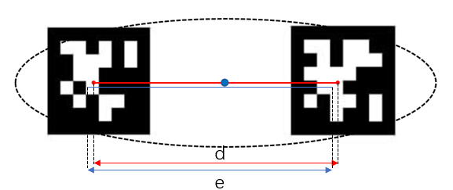

Fig. 4. Schematic diagram of double landmark error estimation

Place the two Apriltags landmarks in parallel on the experiment plate with the camera perpendicular to the marker plate. Take a series of environmental images containing Apriltag tags. After the camera acquires the i frame of the image, the pose of the marker board is obtained according to the actual physical size of the landmark and the size of the landmark in the acquired image, and then the corresponding information is obtained through decoding. The specific formula is as follows:

Two Apriltags

error estimation steps:

The detection position of the two landmarks tag 1 is $\left(x_{1},y_{1}\right)$, the detection position of tag 2 is $\left(x_{2},y_{2}\right)$), and the actual distance between tag1 and tag2 is d.

### The center position

The center position of the two landmarks is:

$$\begin{aligned}\left(x,y\right)=\left(\frac{x_{1}+x_{2}}{2},\frac{y_{1}+y_{2}}{2}\right)\#\left(7\right)\end{aligned}$$

### Error estimation

the measurement error in this frame i is:

$$\begin{aligned}w_{i}=\left|d-\sqrt{{\left(x_{1}-x_{2}\right)}^{2}+{\left(y_{1}-y_{2}\right)}^{2}}\right|\#\left(8\right)\end{aligned}$$

The video frame can be filtered by the error size, and then the interference of lighting or other environmental factors can be eliminated.

### Error confidence

After the optical markers ,pose and information are obtained, the PES method is used to estimate the positioning error. In the i frame image, the actual physical distance between the two optical markers is d, and the camera positioning distance is $e_{i}$, Then the measurement error of the i frame measured is |d-|. Then the stability of the positioning system is obtained according to the variance formula, as follows:

$$\begin{aligned}s^{2}=\frac{\sum_{i=1}^{n}{ }{\left(w_{i}-w\right)}^{2}}{n}\#\left(9\right)\end{aligned}$$

The variance can reflect the stability of the system by measuring the fluctuation of the error data. The smaller the variance value, the more stable the system.

We conducted the error estimation experiment outdoors, and the experimental scene and device are shown in Figure 5.

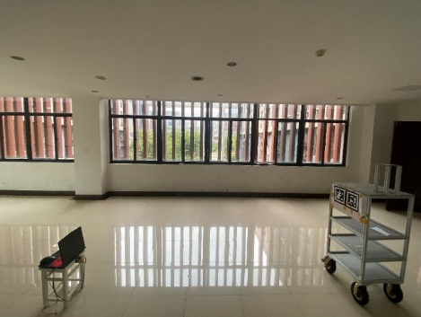

Fig. 5. Schematic diagram of experimental scene and device

In the indoor environment, the vertical distance between the camera and the landmark board measured by the laser rangefinder is 3 m, the test vehicle carrying the landmark moves 0-3.6 m along the X axis, and the average confidence is 4.818 mm; The X-axis direction moves 0-1.2 m, and the average confidence is 8.46 mm; the confidence is shown in Figure 6.

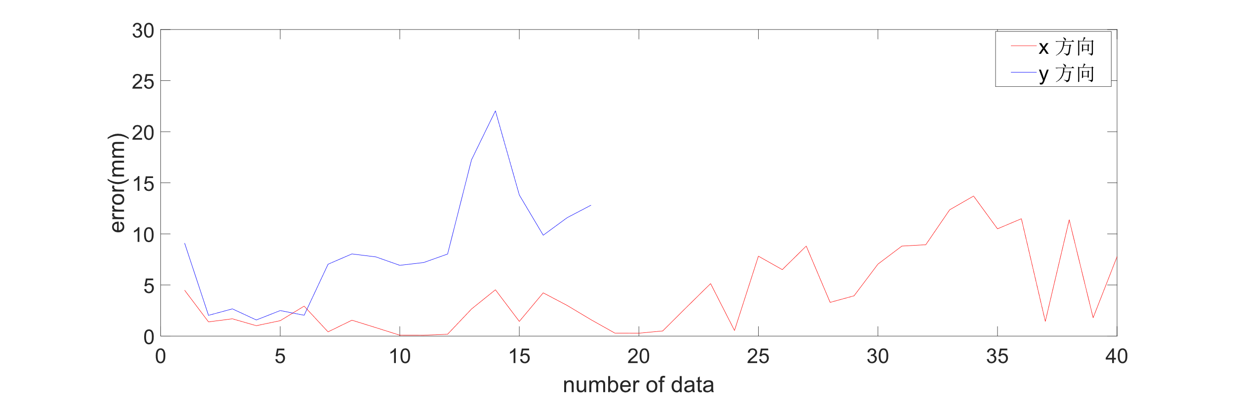

Fig. 6. Experimental confidence

# Template matching vo

This paper uses the template matching visual odometry proposed in [23], while adding IMU to provide angle information. Figure 7 is a schematic diagram of template matching.



Fig. 7. Schematic diagram of template matching

A monocular camera and IMU are installed on the robot, the camera is perpendicular to the ground and a series of images containing ground texture is captured. The camera matching process is shown in Figure 7. Select the center area of the i frame image as the template, $T_{w}$ and $T_{h}$ represent the width and height of the template, respectively, match the $i+1$ frame image, find the rectangular area with the highest similarity, and obtain the template pixels The displacement increments $∆u$ and $∆v$. The actual displacement increment of the robot in the world coordinate system can be obtained by measuring the installation height and internal parameters of the camera. The calculation formula is as follows:

$$\begin{aligned}\begin{aligned}Δx_{r}=Δu\frac{h}{f_{x}} \\ Δy_{r}=-Δv\frac{h}{f_{v}}\end{aligned}\#\left(10\right)\end{aligned}$$

$∆x_{r}$ and $∆y_{r}$ are the displacement increment of the robot in the x and y directions in the robot coordinate, $f_{x}$ and $f_{y}$ are the normalized focal lengths of the camera in the x and y directions, which can be obtained by calibrating the camera. h is the height of the camera from the ground.

Through the rotation angle $θ_{i+1}$ of the robot provided by IMU from time $i$ to time $i+1$, the position of the robot can be obtained. The specific formula is:

$$\begin{aligned}\left[\begin{aligned}x_{r,i+1} \\ y_{r,i+1}\end{aligned}\right]=\left[\begin{aligned}x_{r,i} \\ y_{r,i}\end{aligned}\right]+\left[\begin{matrix}\cos{θ_{i+1}} & -\sin{θ_{i+1}} \\ \sin{θ_{i+1}} & \cos{θ_{i+1}}\end{matrix}\right]\left[\begin{aligned}Δx_{r,i+1} \\ Δy_{r,i+1}\end{aligned}\right]\#\left(11\right)\end{aligned}$$

$\left[\begin{aligned}x_{r,i+1} \\ y_{r,i+1}\end{aligned}\right]$ is the coordinate of the robot in the world physical coordinate system at the time $i+1$, $\left[\begin{aligned}x_{r,i} \\ y_{r,i}\end{aligned}\right]$ is the coordinate of the robot in the world physical coordinate system at the time $i$. $\left[\begin{matrix}\cos{θ_{i+1}} & -\sin{θ_{i+1}} \\ \sin{θ_{i+1}} & \cos{θ_{i+1}}\end{matrix}\right]$ is the rotation matrix at the time $i+1$, ${∆x}_{r,i+1}$ and ${∆y}_{r,i+1}$ are the position increments of the robot in the x and y directions of the world physical coordinate system at the time 𝑖+1, respectively.

We conduct a template matching visual odometry localization experiment on an indoor marble pavement. The experimental scene and the corresponding pavement image are shown in Fig 8.

 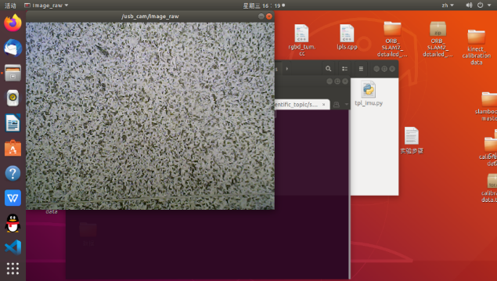

(a) (b)

Fig. 8. Template matching experimental scene

(a)Indoor scene (b) Marble floor

The experimental trajectory is shown in Fig 9. On the indoor marble pavement, the AB distance measured by the laser rangefinder is 5.4 m, and the template matching visual odometry is 5.417 m.



Fig. 9. Experimental results

# UnitsPose estimation method based on the fusion of MCPES and template matching visual odometry

When the camera tracking and positioning of the optical marker become unstable due to environmental factors, such as lighting, etc., Apriltag may experience positioning drift, resulting in positioning failure. We can combine the two optical markers to form a marker group and use PES to estimate the error. The data with larger errors can be eliminated accordingly, and the robustness of the system can be judged by calculating the variance of the error. This paper uses two monocular cameras facing the ground, collects environmental information and runs MCPES to locate and track landmarks in different rooms, and cooperates with dual optical marker groups to improve the robustness of the system. The monocular camera facing the ground and the IMU constitute a template matching visual odometry. The specific process is shown in Figure 10.

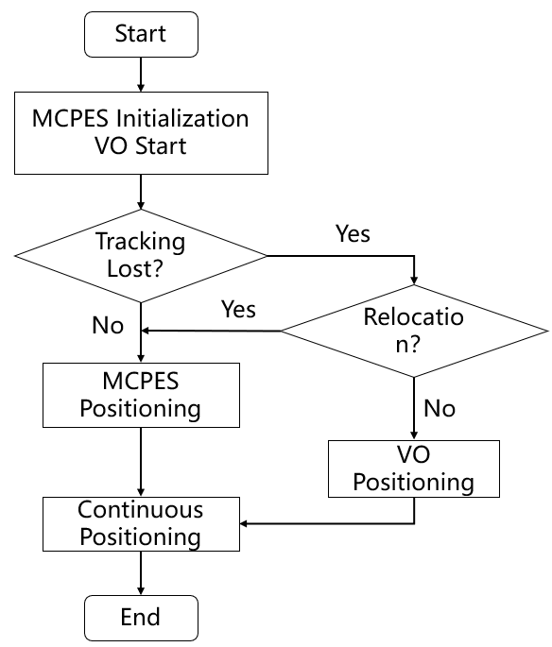

Fig. 10. MCPES and template matching visual odometry joint localization

# Experiment

The experiment is carried out using an industrial computer with ubuntu18.04 version, the processor is Intel® CoreTMi5-7300 CPU, and the running memory is 8G. The experimental platform is shown in the figure, including two fluorite monocular cameras, the model is 1280*720, and the frequency is 30Hz.

## Experiment in the indoor real scene.

The camera is placed on the ceiling, facing the ground vertically, 2.875m from the ground. The double landmark board is placed on top of the robot.

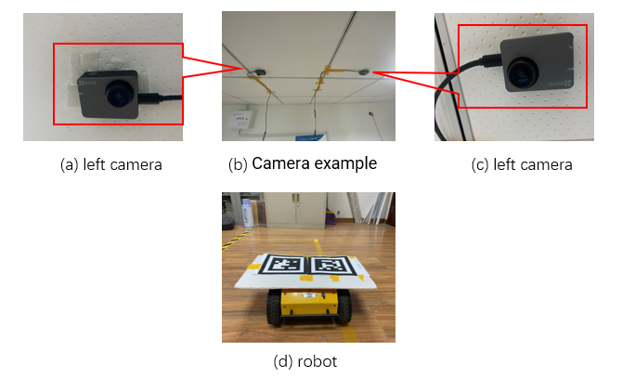

Fig. 11. Experimental data collection platform

In the indoor environment, the mobile experimental platform drives a circular trajectory. The actual scene is shown in Figure 11. The robot is controlled to move along a circle with a radius of 0.7 m, and the distance from the center of the circle to the center of the landmark is 0.795 m. Drive on a trajectory with a radius of 0.795 m.

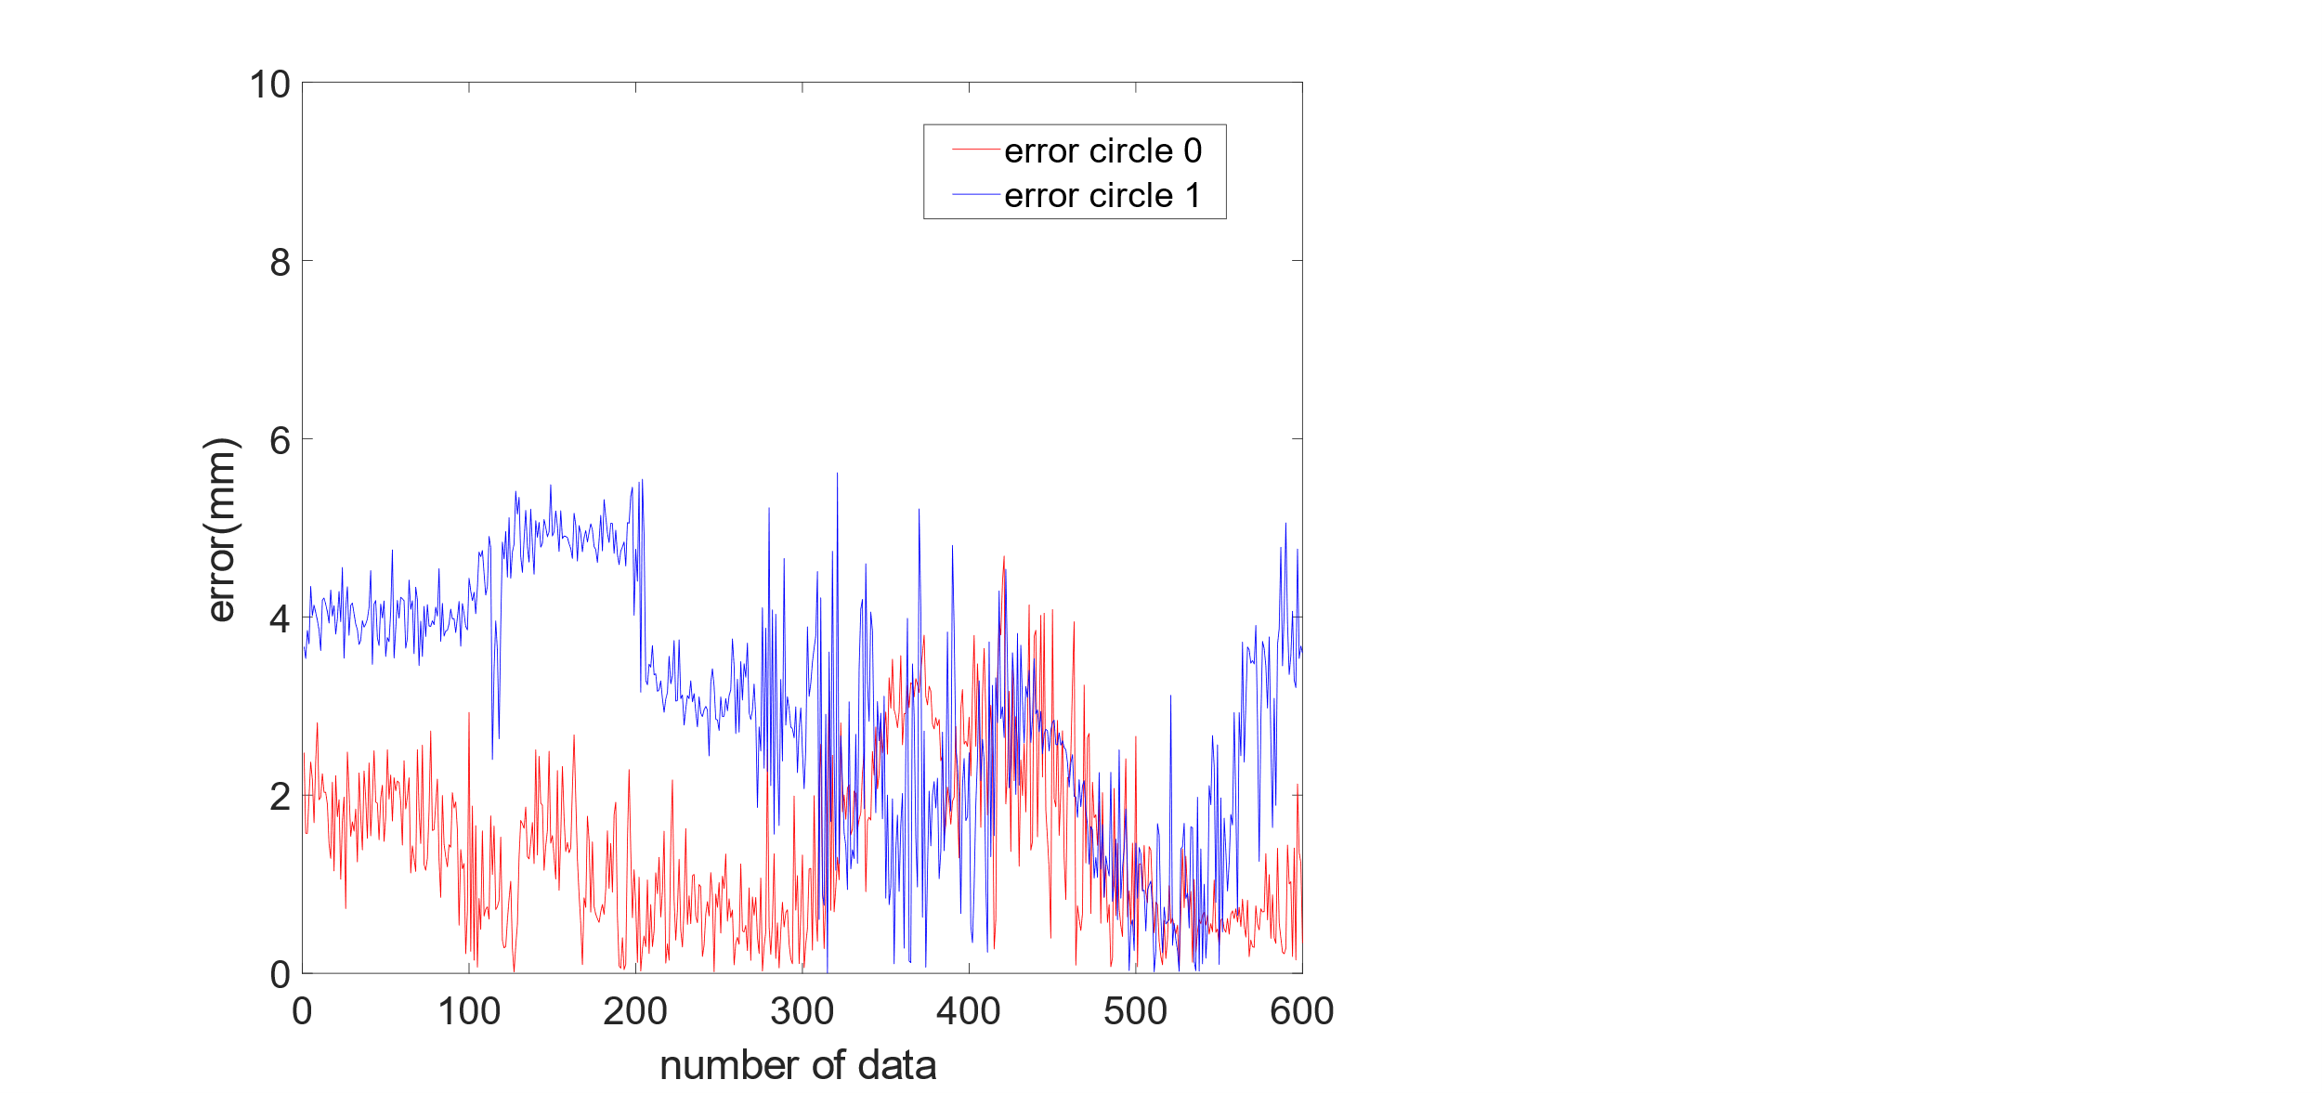

(a) (b)

Fig. 12. Circular experimental trajectory and error

(a)Robot trajectory (b) Error estimate

The circular experimental results are shown in Fig 12, and the output trajectory basic coincides with the real trajectory. The experimental error is the absolute value of the difference between the actual coordinate and the radius of the rotation center. The maximum error does not exceed 20mm, which meets the actual indoor positioning needs.

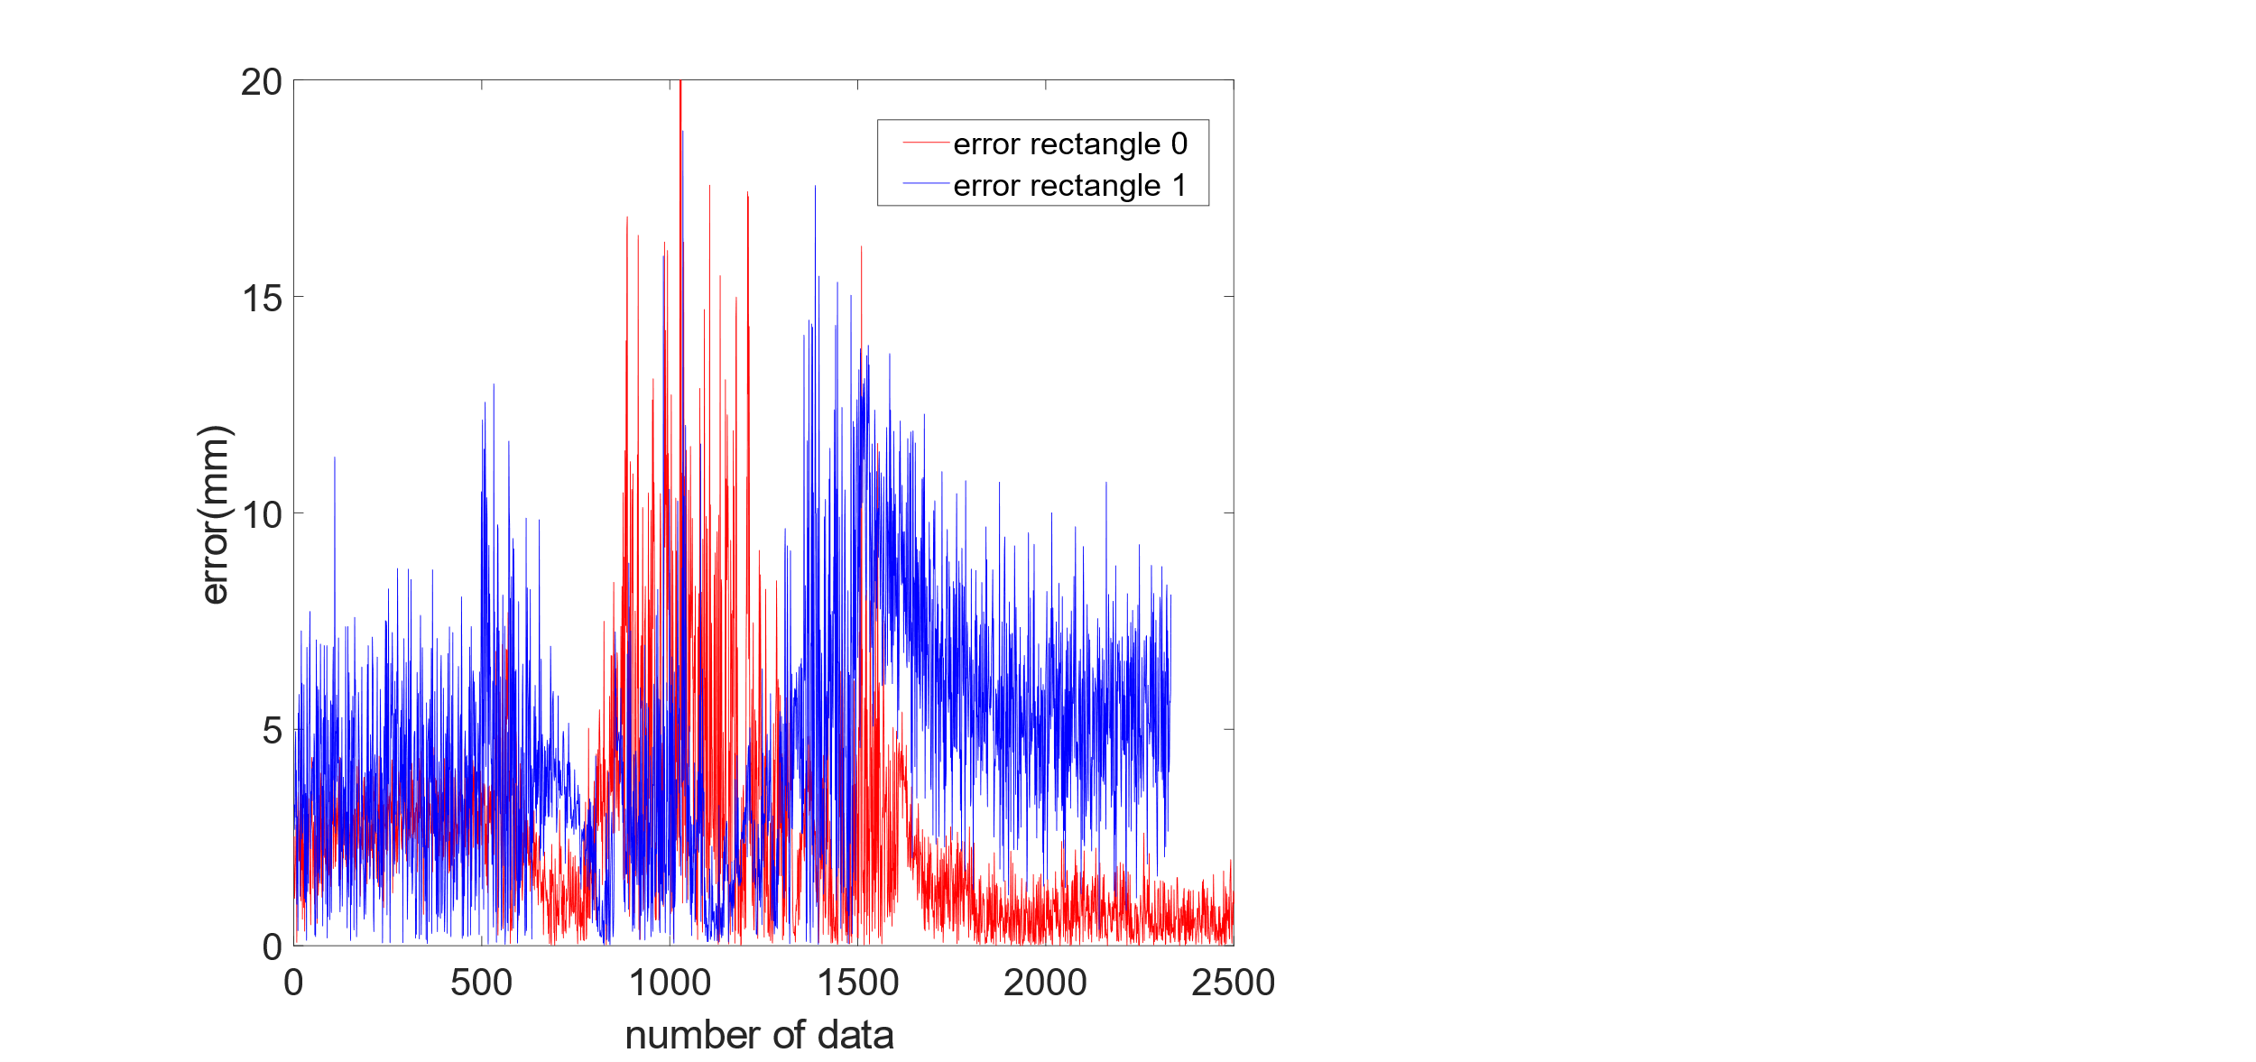

(a) (b)

Fig. 13. Rectangular trajectory experiment

(a)Robot trajectory (b) Error estimate

The rectangular experimental results are shown in Fig 13, (a) is the movement trajectory of the cam_0 and cam_1 positioning robot, and (b) is the confidence of the two-camera positioning labels. It can be seen that the maximum confidence does not exceed 20 mm.

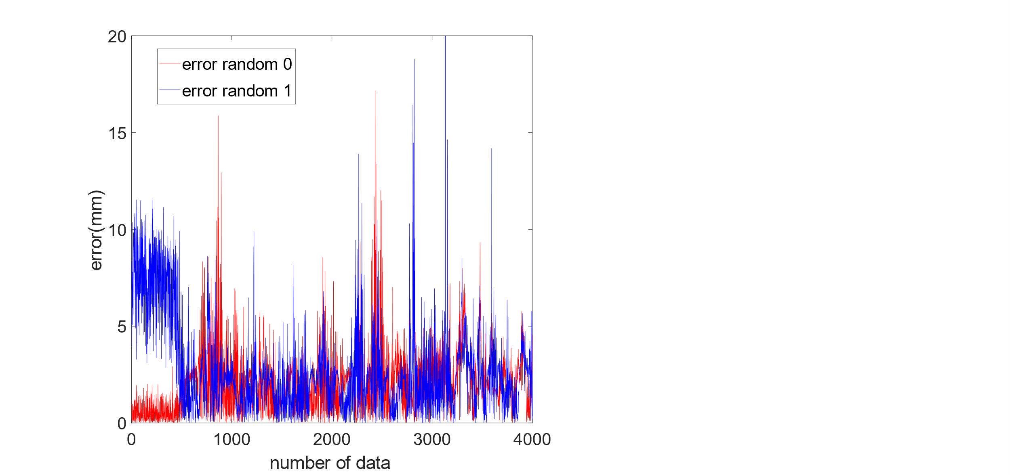

(a) (b)

Fig. 14. Random trajectory experiment

The random path experiment is shown in Fig 14, (a) is the moving trajectory of cam_0 and cam_1 positioning the robot, (b) is the confidence of the two-camera positioning label, it can be seen that the maximum confidence is not more than 20 mm.

## Algorithm Robustness Experiment

The experimental scene is shown in Fig 15, and the robot's running trajectory is points A, B, C, and D. During the experiment, the robot has no field of view in the ab segment cam_1, and the CD segment cam_0 has no field of view. The experimental trajectory is shown in Figure 15. Position and draw the trajectory in cam_0 in the AB segment, cam_1 has no field of view; only cam_1 in the CD segment locates and draws the trajectory, and cam_0 has no field of view; both cameras in the BC segment can draw the trajectory. Through our multi-camera joint positioning system, the robot can achieve precise positioning in scalable indoor complex scenes.

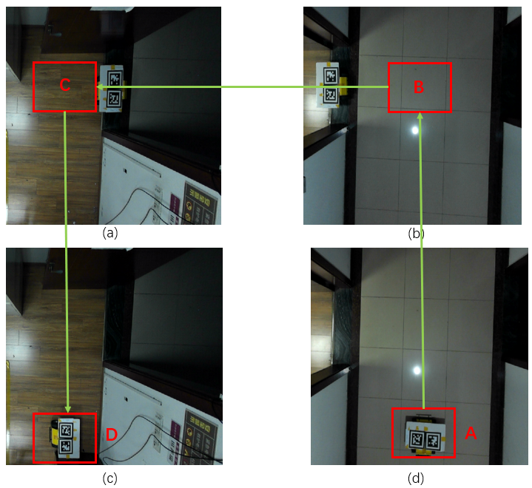

Fig. 15. Robot shuttle experiment from different camera fields of view

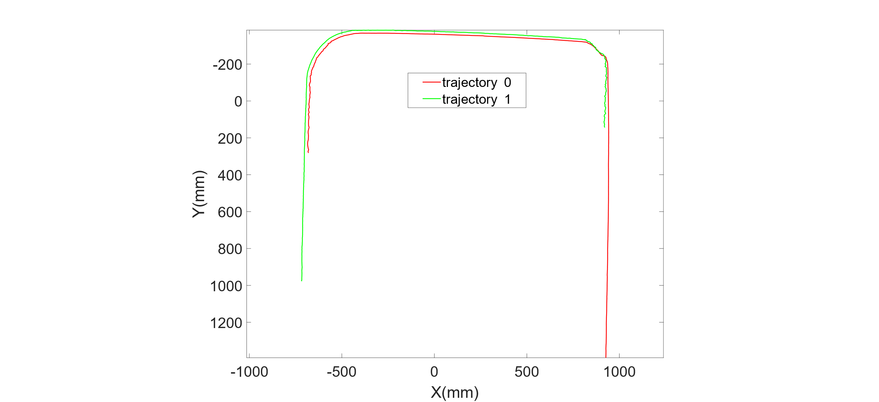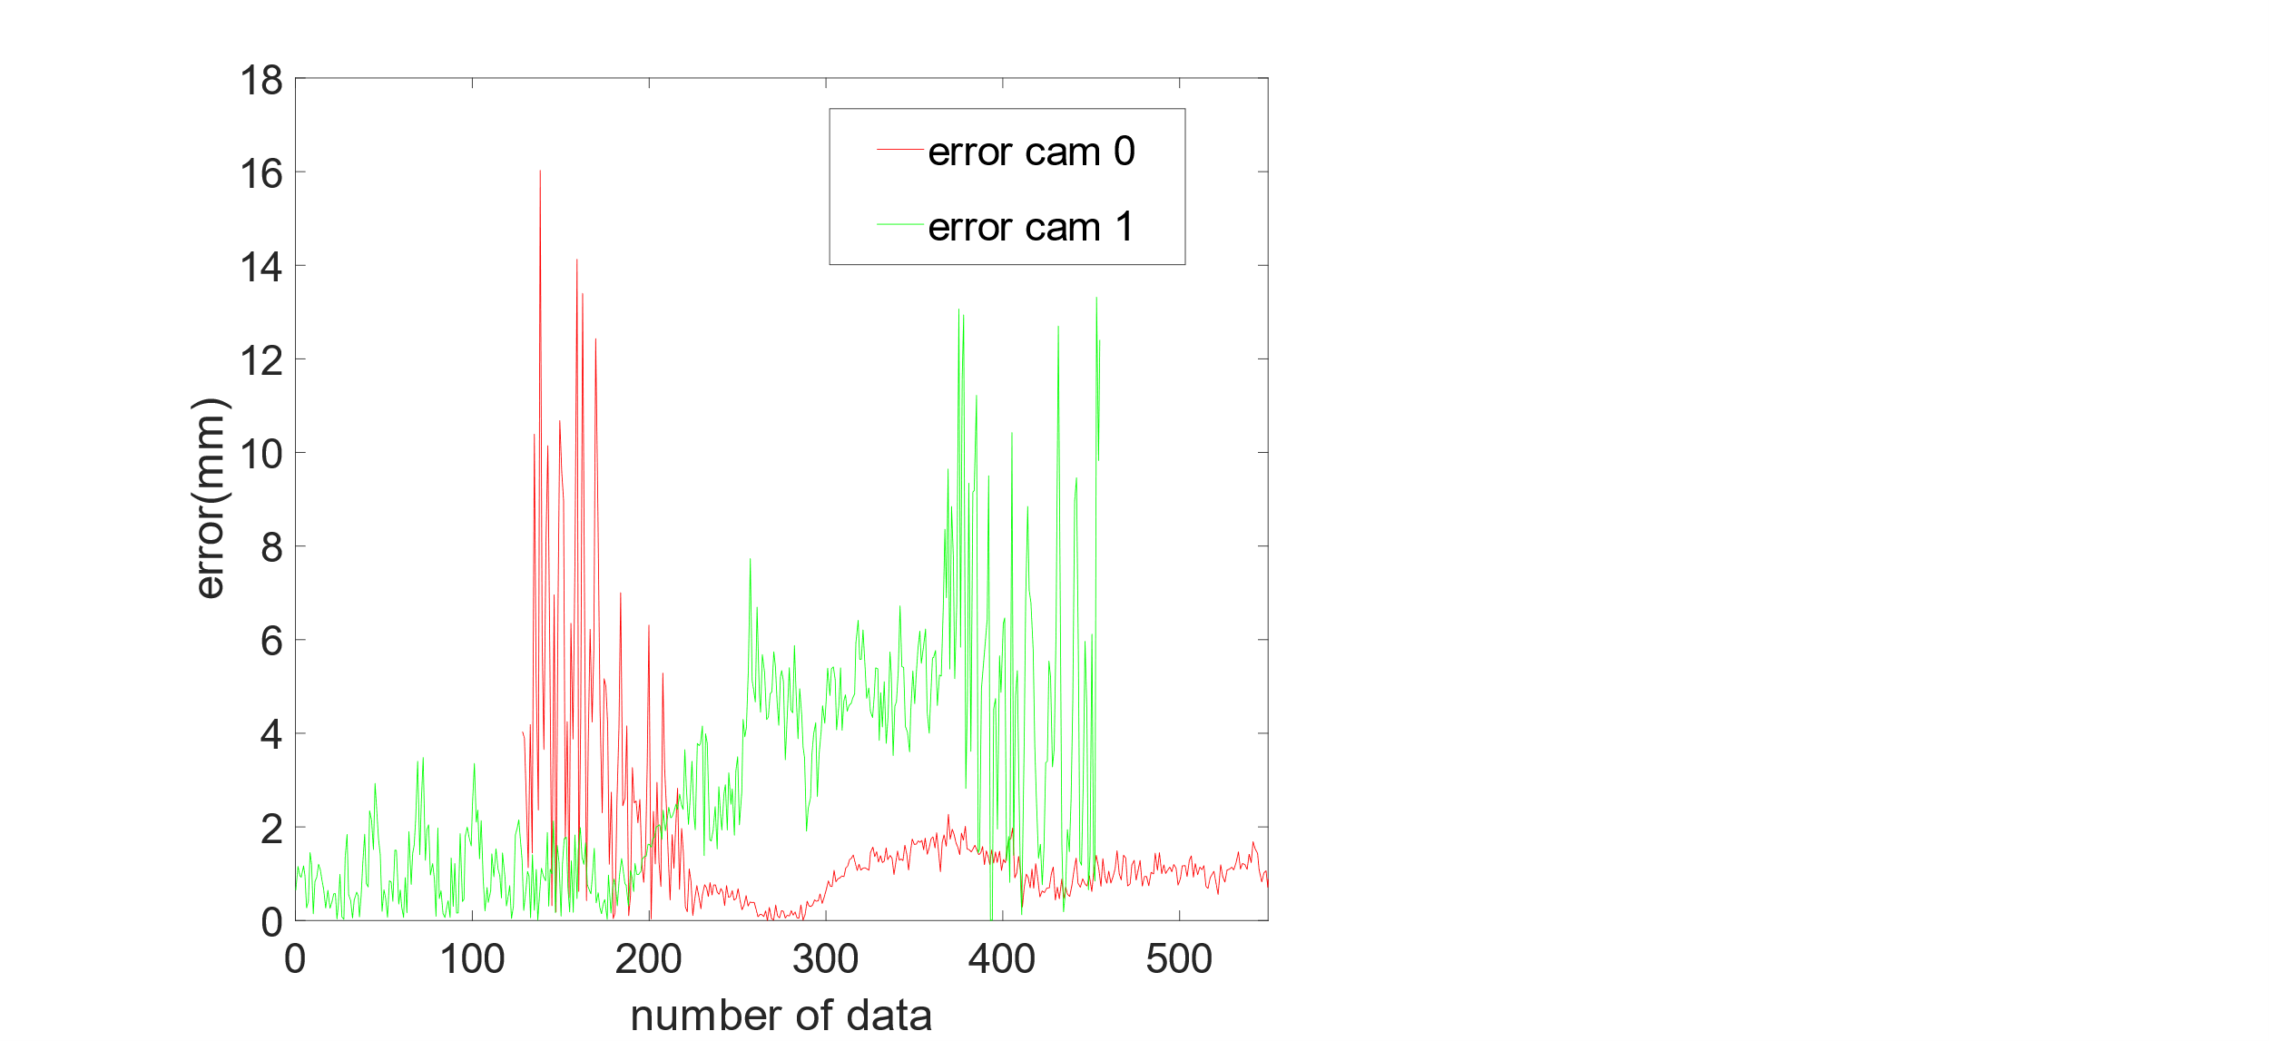

(a) (b)

Fig. 16. Experimental results

The shuttle experimental trajectory is shown in Fig 16, (a) is the experimental trajectory, red indicates the cam_0 positioning trajectory, green indicates the cam_1 positioning trajectory and (b) is the fixed position reliability value, within 20 mm. The method in this paper can realize multi-camera joint localization, and after the localization of a single camera is lost, another camera can continue to localize.

## Lost target experiment

The red line represents the running trajectory. During the experiment, the robot moved out of the monitoring range of the ceiling camera. The experimental trajectory is shown in Fig 17. When the MCPES tracking is lost, the positioning cannot be continued. The joint algorithm of MCPES and template matching visual odometry can achieve continuous localization after tracking loss.

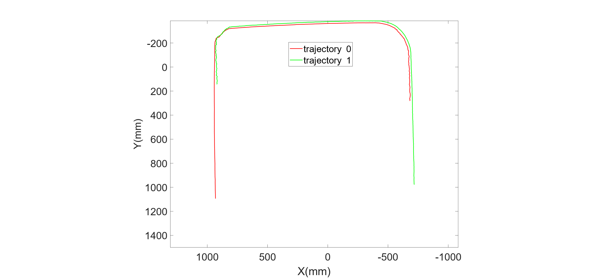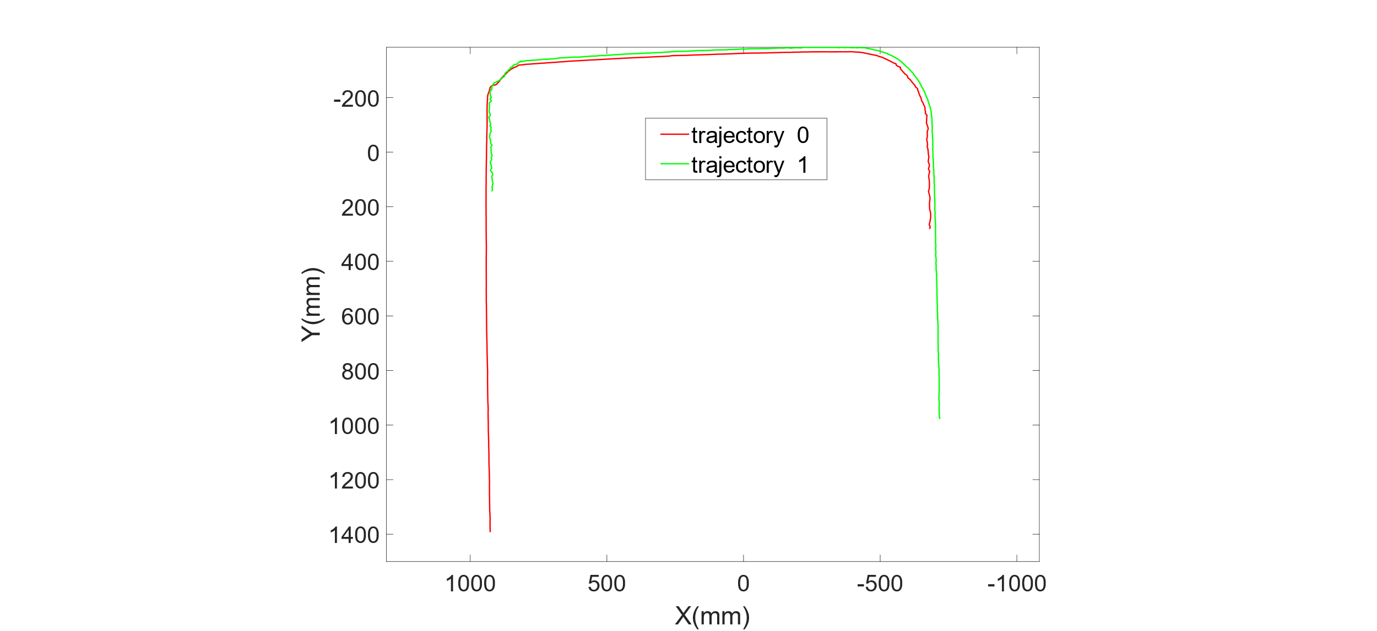

(a) (b)

Fig. 17. Experimental results

(a) MCPES (b) MCPES+VO

# Conclusion

This paper proposes a localization method for indoor scalable scenes. The method first uses the monocular camera to obtain the position information of the target, establishes the camera coordinate system, and then expands the wide-area viewing angle through a pair of camera coordinate systems. The robot is then positioned using two landmarks, and the confidence of the system's positioning is output by comparing the real distance of the landmark with the measured distance. The experimental results show that the method can obtain the precise positioning of the target in real-time. On the one hand, this method has strong scalability and can perform map expansion in any indoor environment, On the other hand, because this system is external positioning, the robot itself does not need to process positioning information, which can save a certain cost, and a single processor is easier Multi-robot collaborative work is carried out and experiments show that the accuracy of the positioning system is 20 mm, and the MCPES and template matching visual odometry can still achieve continuous positioning even when the camera loses the field of view, which verifies the robustness of the method.

# References

1. Shim J H, Cho Y I. A mobile robot localization using external surveillance cameras at indoor[J]. Procedia Computer Science, 2015, 56: 502-507.
2. Lim H, Lee Y S. Real-time single camera SLAM using fiducial markers[C]//2009 ICCAS-SICE. IEEE, 2009: 177-182.
3. Baltes J. A benchmark suite for mobile robots[C]//Proceedings. 2000 IEEE/RSJ International Conference on Intelligent Robots and Systems (IROS 2000)(Cat. No. 00CH37113). IEEE, 2000, 2: 1101-1106.
4. Bacik J, Durovsky F, Fedor P, et al. Autonomous flying with quadrocopter using fuzzy control and ArUco markers[J]. Intelligent Service Robotics, 2017, 10 (3): 185-194.
5. Bostelman R, Hong T, Cheok G. Navigation performance evaluation for automatic guided vehicles[C]//2015 IEEE International Conference on Technologies for Practical Robot Applications (TePRA). IEEE, 2015: 1-6.
6. Burgard W, Stachniss C, Grisetti G, et al. A comparison of SLAM algorithms based on a graph of relations[C]//2009 IEEE/RSJ International Conference on Intelligent Robots and Systems. IEEE, 2009: 2089-2095.
7. Rowley H A, Baluja S, Kanade T. Neural network-based face detection[J]. IEEE Transactions on pattern analysis and machine intelligence, 1998, 20(1): 23-38.
8. Scharstein D, Szeliski R. A taxonomy and evaluation of dense two-frame stereo correspondence algorithms[J]. International journal of computer vision, 2002, 47(1): 7-42.
9. Smith M, Baldwin I, Churchill W, et al. The new college vision and laser data set[J]. The International Journal of Robotics Research, 2009, 28(5): 595-599.
10. Amigoni F, Gasparini S, Gini M. Good experimental methodologies for robotic mapping: A proposal[C]//Proceedings 2007 IEEE International Conference on Robotics and Automation. IEEE, 2007: 4176-4181.
11. Bonarini A, Burgard W, Fontana G, et al. Rawseeds: Robotics advancement through web-publishing of sensorial and elaborated extensive data sets[C]//In proceedings of IROS. 2006, 6: 93.
12. Ceriani S, Fontana G, Giusti A, et al. Rawseeds ground truth collection systems for indoor self-localization and mapping[J]. Autonomous Robots, 2009, 27(4): 353-371.
13. Kümmerle R, Steder B, Dornhege C, et al. On measuring the accuracy of SLAM algorithms[J]. Autonomous Robots, 2009, 27(4): 387-407.
14. Kikkeri H, Parent G, Jalobeanu M, et al. An inexpensive method for evaluating the localization performance of a mobile robot navigation system[C]//2014 IEEE International Conference on Robotics and Automation (ICRA). IEEE, 2014: 4100-4107.
15. Li Y, He L, Zhang X, et al. Multi-sensor fusion localization of indoor mobile robot[C]//2019 IEEE International Conference on Real-time Computing and Robotics (RCAR). IEEE, 2019: 481-486.
16. Scaramuzza D, Fraundorfer F. Visual odometry [tutorial][J]. IEEE robotics & automation magazine, 2011, 18(4): 80-92.
17. Kicman P, Narkiewicz J. Concept of integrated INS/visual system for autonomous mobile robot operation[J]. Marine Navigation and Safety of Sea Transportation, 2013,35.
18. Babinec A, Jurišica L, Hubinský P, et al. Visual localization of mobile robot using artificial markers[J]. Procedia Engineering, 2014, 96: 1-9.
19. Olson E. AprilTag: A robust and flexible visual fiducial system[C]//2011 IEEE international conference on robotics and automation. IEEE, 2011: 3400-3407.
20. Wang J, Olson E. AprilTag 2: Efficient and robust fiducial detection[C]//2016 IEEE/RSJ International Conference on Intelligent Robots and Systems (IROS). IEEE, 2016: 4193-4198.
21. Chu C H, Yang D N, Chen M S. Image stablization for 2D barcode in handheld devices[C]//Proceedings of the 15th ACM international conference on Multimedia. 2007: 697-706.
22. Cormen T H, Leiserson C E, Rivest R L, et al. Introduction to algorithms[M]. MIT press, 2022.
23. Zeng Q, Ou B, Lv C, et al. Monocular Visual Odometry Using Template Matching and IMU[J]. IEEE Sensors Journal, 2021, 21(15): 17207-17218.

|  |
| --- |
|  |
|  |

**Jianhao Yu received her B.S. degree from Anhui University of Technology, Anhui, in 2020. She is currently working toward her M.S. degree at Field Robotics Laboratory in Nanjing University of Aeronautics and Astronautics, China. Her research interests include positioning and navigation of unmanned ground vehicles, Multi-sensor fusion systems.**

**Yuhua Huang received his B.S. degree in communication engineering from Harbin Institute of Technology, Harbin, China in 1996, Master degree in communication & information system from Xinjiang University, Urumuqi, China in 2002 and Ph.D. degree in signal & information process from Southeast University, Nanjing, China in 2006. He is currently an associate professor in the Computer Center, Nanjing University of Aeronautics & Astronautics, China. His research interests include WSN with its security.**



**Qingxi Zeng received his B.S. degree in electrical engineering and automation from Harbin Institute of Technology, Harbin, China, in 2002 and Ph.D. degree in instrument science and technology from Southeast University, Nanjing, China, in 2009. In 2018 he was a visiting scholar in the Robotics Institute Carnegieement Mellon University, USA. He is currently an associate professor with the College of Automation Engineering, Nanjing University of Aeronautics and Astronautics, China. His research interests include positioning and navigation of unmanned ground vehicles, Multi-sensor fusion systems.**

**HaoNan Yu was born in Jiangsu Province, China in 1999. He received his B.S. degree from Yangzhou University, China in 2021. He is currently a M.S. student at the College of Automation Engineering, Nanjing University of Aeronautics and Astronautics. His research interest includes SLAM and robot vision.**

1. Manuscript created October 8th, 2022. This work was supported by the Fundamental Research Funds for the Central Universities (Grant No. NJ2022019-5). Jianhao Yu and Yuhua Huang are with the College of Computer Science and Engineering, Nanjing University of Aeronautics and Astronautics. Qingxi Zeng and HaoNan Yu are with the College of Automation Engineering, Nanjing University of Aeronautics and Astronautics, the Key Laboratory of Nuclear Technology Application and Radiation Protection in Astronautics (Nanjing University of Aeronautics and Astronautics), Ministry of Industry and Information Technology, and Nondestructive Detection and the Monitoring Technology for High Speed Transportation Facilities, Key Laboratory of Ministry of Industry and Information Technology, Nanjing, 211106 China (e-mail: autonavinuaa@163.com).